Title: Times new roman 12 Bold
By: Times New Roman 11
Supervisor: Times New Roman 11
Advisor: Times New Roman 11
ABSTRACT: Times New Roman 11, Please provide an abstract of 150 to 250 words. The abstract should not contain any undefined abbreviations or unspecified references. describe briefly the introduction, target and results. Times New Roman 11, Please provide an abstract of 150 to 250 words. The abstract should not contain any undefined abbreviations or unspecified references. describe briefly the introduction, target and results. Times New Roman 11, Please provide an abstract of 150 to 250 words. The abstract should not contain any undefined abbreviations or unspecified references. describe briefly the introduction, target and results. Times New Roman 11, Please provide an abstract of 150 to 250 words. The abstract should not contain any undefined abbreviations or unspecified references. describe briefly the introduction, target and results. Times New Roman 11, Please provide an abstract of 150 to 250 words. The abstract should not contain any undefined abbreviations or unspecified references. describe briefly the introduction, target and results. Times New Roman 11, Please provide an abstract of 150 to 250 words. The abstract should not contain any undefined abbreviations or unspecified references. describe briefly the introduction, target and results.
Keywords: Immediately after the abstract, provide a maximum of 6 keywords, Times New Roman 11.

Graphical abstract:
The graphical abstract should summarize the contents of the research in a concise, pictorial form designed to capture the attention of a wide readership.
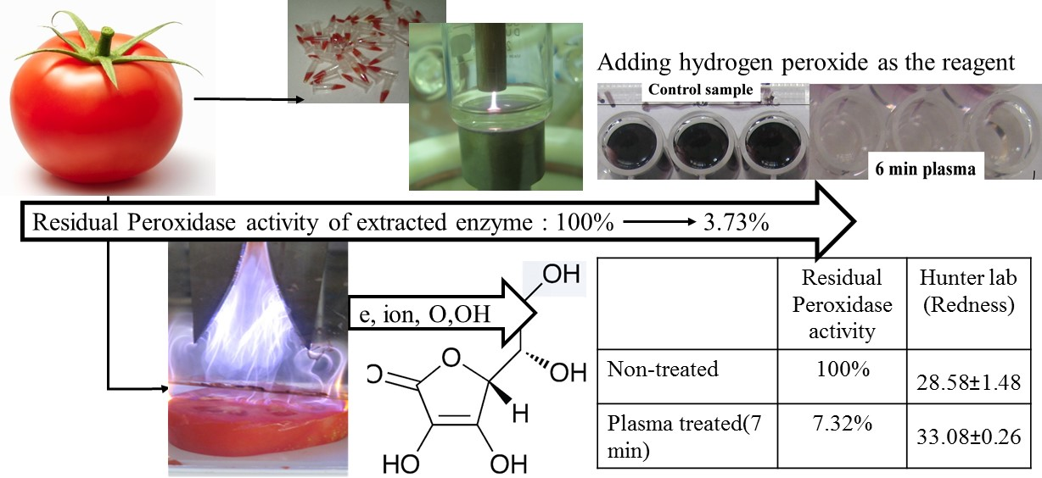

Highlights
- Highlight is consisting of a short collection of bullet points that convey the core findings of the article. Times new roman 11.
- Highlight is consisting of a short collection of bullet points that convey the core findings of the article. Times new roman 11.
- Highlight is consisting of a short collection of bullet points that convey the core findings of the article. Times new roman 11.
- Highlight is consisting of a short collection of bullet points that convey the core findings of the article. Times new roman 11.
References
Number the references (numbers in square brackets) in the list in the order in which they appear in the text. Times new roman 9.
Examples:
- Reference to a journal publication: [1] J. van der Geer, J.A.J. Hanraads, R.A. Lupton, The art of writing a scientific article, J. Sci. Commun.
163 (2010) 51–59.
- Reference to a book: [2] W. Strunk Jr., E.B. White, The Elements of Style, fourth ed., Longman, New York, 2000.

